**SYDE-3203-07 Final Project:**

**Evolve Hardware Company**

**By:**

**Stevenson Suhardy, Cole Biglang-awa, Alejandro Perez Sanabria**

asda

**Table of Contents**

Introductory Memo 2

System Request 3

Feasibility Analysis 6

Use Case Diagram(s) 11

Activity Diagrams 14

Use Case Descriptions 20

Class Diagram 32

# 

# **Introductory Memo**

Addressing Evolve Hardware’s lack of online Customer Service:

The company is currently in decline because many customers are having problems with the company’s products, but they are unable to contact them through any means except, for going to the store or the company itself. Evolve Hardware does not know how to improve this since they do not have any experience in making an online customer service and they have not received any feedback on how to improve from the customers as well due to offline limitations. That is where we come in. We are going to provide a new online customer service system for Evolve Hardware to help them improve with the feedback they will get from the customers, and also they can solve the customers’ problems without having to trouble the customer to come in-person.

To learn more about the business’ problem, we visited other websites such as Best Buy and Durham College to grasp the concept of what an online customer-to-employee and customer-to-product interaction should look like. Through these, we were able to acquire the necessary knowledge on website activity, feedback reviews, and live chat experience to apply it to our deliverables.

# **System Request**

| System Request: | Evolve Hardware’s New Online Customer Service System |
| --- | --- |
| Project Sponsor: | Stephen Forbes |
| Business Need: | Evolve Hardware’s lack of online customer service has been one of the major causes for its rapid economic decline and the loss of many customers. Since customers don't have a way to communicate with the company other than by calling we need to create a new website for the business where customers can communicate with the company remotely . |
| Business Requirements: | Functional:   1. Create optimal interaction between personnel and customers. 2. Customers can leave ratings for the system for feedback and constant improvement. 3. System will provide a detailed overview of costs. 4. Service should implement an online payment system for customers 5. System must allow customers to live chat with the company customer service department after the customer has entered their name and email address. 6. Easy navigation that non-tech savvy users can utilize.   Non-functional:   1. Operational -    1. Online Customer Service should closely resemble face-to-face service and function on desktop/mobile devices    2. Website and system must be able to open in popular web browsers like Edge, Firefox, Chrome. 2. Performance -    1. Service should be robust in that it holds up despite an overload of requests in the server.    2. System should not take more than 7 seconds to load.    3. System must be able to take on at least hundreds of users at the same time. 3. Security - Personal data access is reserved for customers (e.g transactions) 4. Cultural & Political -    1. The system should ask for the customer’s location and offer service in their language    2. System must not contain any offensive word from any language possible. |
| Business Value: | Tangible:   1. Decreased process times for customers who have complaints about the product. 2. Increased product sales. 3. More positive reviews from customers. 4. Higher quality product production because of external and internal feedback about the product rather than internal only. 5. Higher quality product production because of external and internal feedback about the product rather than internal only.   Intangible:   1. Increased customer’s satisfaction because they have a way to give feedback and complain about any issues they have with the product. 2. Increased product recognition by the public. |
| Special Issues or Constraints: | 1. Project and implementation must be finished by 15/12/2022 2. Our group does not have any prior web design experience to create a nice user experience website. 3. Lack of employees to work on the project. 4. Evolve Hardware must hire more employees to maintain all the new systems that are going to be built and also, for the customer service department. |

# **Feasibility Analysis**

Technical Feasibility: Can We Build It?

|  |
| --- |
| Familiarity with Functional area: Less familiarity generates more risk |
| * The team's knowledge of the functional areas of the business has increased over the development of the software because of the various meetings with the project champion and the customer service department. |
| Familiarity with Technology: Less familiarity generates more risk |
| * As a Hardware company, the team is comfortable working with desktop computers and laptops in terms of setting them up as well as operating/troubleshooting them. * However, our software skills are lacking in terms of front end and back end web development. We lack skills in the necessary coding languages (HTML, PHP) and we are not well-versed with the use of text editors such as the industry standard Visual Studio Code for web development. |
| Project Size: Large Projects have more risk |
| * This project will be a large-sized project because we need to create a website from scratch and also integrate it with the company’s existing data system. Making a website can be complicated because there are a lot of different features that can be added but, for this project we are going to mainly focus on the customer service on the website and some other features, where users, except for customers, login to access data about customers. Lots of risks are unavoidable because this is a large project for only 3 employees. |
| Compatibility: The harder it is to integrate the system with the company’s existing technology, the higher the risk |
| * The technology being developed is going to be hard to implement with the current system since it will require that the business acquire hardware to make our system work, as well as making sure all the employees can use the computers and know their way around the system. |

Economic Feasibility: Should We Build It?

Tangible Costs and Benefits:

Benefits:

1. Increased Sales: $200,000

Total Benefits: $200,000

Development Costs:

Hardware:

1. Server: $1,872
2. External Hard Drive / Backup: $399.99
3. Computer / Laptops: $0 (Evolve Hardware already has powerful computers.)
4. Internet: $64.99 / month

Software:

1. Database (SQL Server 2019 Standard): $4,260
2. Visual Studio Code: $0
3. PHP: $0
4. HTML: $0

Service:  
Buying a website design from a third-party company: $7,500

Training Materials

How to build a Customer Service Live-Chat: $0

How to install a Server: $0

Training Hours and Work Hours

Note: Assuming that employees will be paid $35 per hour and there are only 3 employees or back-end developers because there are only 3 group members and we work 8 hours a day and 5 days a week.

One-month period of training: 35 * 40 * 4 = $5,600 – taxes = $4,872 * 3 = $14,616

The project will be completed around mid-December 2022 so, we have around roughly 3 months before our deadline for the system comes. Adding the training period, we only have about 2 months to complete the customer service system.

Two-month work period: 35 * 40 * 8 = $11,200 – taxes = $9,744 * 3 = $29,232

The work period will mainly be coding and SCRUM meetings to keep each other updated and help each other if there is anything that is holding us back. And around the last 2 weeks of the work period, we will be conducting tests for the website and making any last-minute changes to the website.

Total Costs:

Hardware + Software + Service + Training Materials + Training Hours

Total = $60,169.59

Intangible Costs and Benefits

Costs:

|  |
| --- |
| 1. Employees have to learn to use the new system which might take some time.   Benefits:   1. Employees will have an easier time helping customers. 2. Company recognition by the customers. |
|  |

Organizational Feasibility: If We Build It, Will They Come?

|  |
| --- |
| Strategic Alignment |
| Stakeholders |
| * Is the project strategically aligned with the business?   + Yes, the project is strategically aligned with the business. The project will help the business to gain recognition from the customers because they are trying to help customers to file a complaint easier, or maybe the customers need help from the company. Rather than going to the company, there will be an online service for them to contact. It will be better for the company in the long run since they will have more loyal customers because they appreciate the company caring about its customers. |
| * Project Champion(s): Alejandro Perez Sanabria |
| * Senior Management: Cole Biglang-awa, Stevenson Suhardy |
| * Users: Evolve Hardware’s New Customer Service Department |
| * Other stakeholders: Evolve Hardware employees (Provide the hardware resources), Testers (They perform the hands-on testing the functionality of the website and software) |

Additional Comments

|  |
| --- |
| Hardware and Software Prices Reference:  Server:  [https://www.lenovo.com/ca/en/p/servers-storage/servers/towers/thinksystem-st650-v2/len21ts0001?cid=ca:sem|se|google|DCG+eCommD_PLA_NonBrand_CA_DCF||||10443733120|103596613397|pla-1432386577323|shopping|nonbrand|&gclid=CjwKCAjw7p6aBhBiEiwA83fGuscS1A15GXdnuLM81mBdDUtABK_H2aL5H740UquN5vScCjp9hy04nRoCC0oQAvD_BwE](https://www.lenovo.com/ca/en/p/servers-storage/servers/towers/thinksystem-st650-v2/len21ts0001?cid=ca:sem%7Cse%7Cgoogle%7CDCG+eCommD_PLA_NonBrand_CA_DCF%7C%7C%7C%7C10443733120%7C103596613397%7Cpla-1432386577323%7Cshopping%7Cnonbrand%7C&gclid=CjwKCAjw7p6aBhBiEiwA83fGuscS1A15GXdnuLM81mBdDUtABK_H2aL5H740UquN5vScCjp9hy04nRoCC0oQAvD_BwE)  External Hard Drive (WD Easystore 14 TB USB 3.0):  <https://www.bestbuy.ca/en-ca/product/wd-easystore-14tb-usb-3-0-desktop-external-hard-drive-wdbama0140hbk-nese-black-only-at-best-buy/14936770?cmp=seo-14936770&cmp=knc-s-71700000075212937&gclid=CjwKCAjw7p6aBhBiEiwA83fGujHdXV_skkrln8nu42A2QWK6lxPLzO33XC7-1UmSQw0DlpjiTVlILxoCKHQQAvD_BwE&gclsrc=aw.ds>  SQL Server 2019 Standard Edition:  <https://www.microsoft.com/en-ca/d/SQL-Server-2019-Standard-Edition/DG7GMGF0FKX9?activetab=pivot:overviewtab>  Web Design Service:  <https://ca.godaddy.com/blog/how-much-does-it-cost-to-build-a-website-in-canada/> |

# **Use Case Diagram(s)**

High-Level Overview Use Case Diagram:

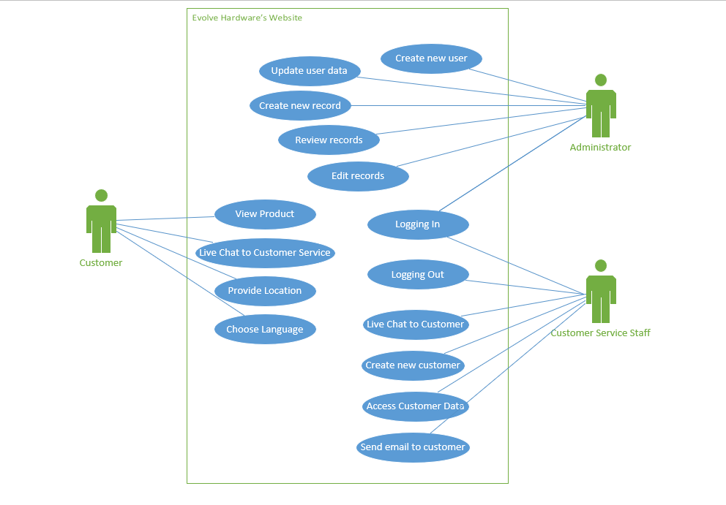

**Customer Use Case Diagram**:

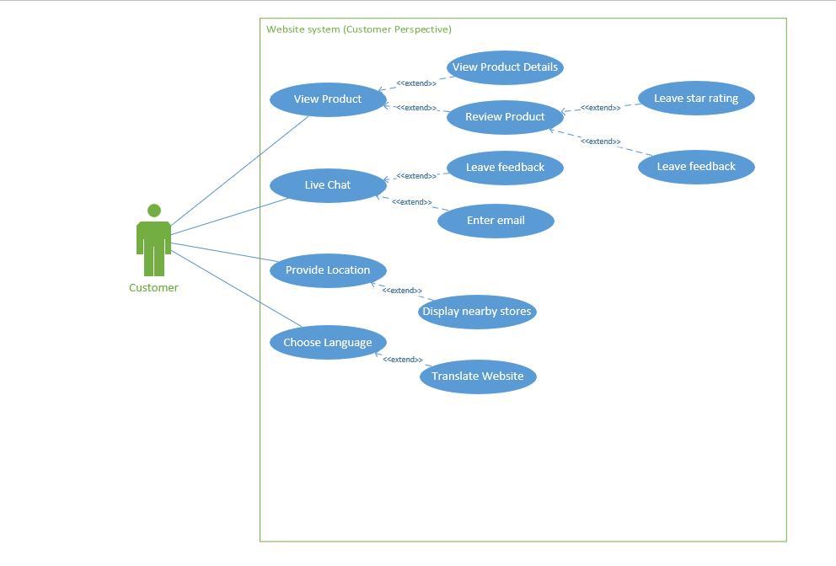

**Administrator Use Case Diagram**:

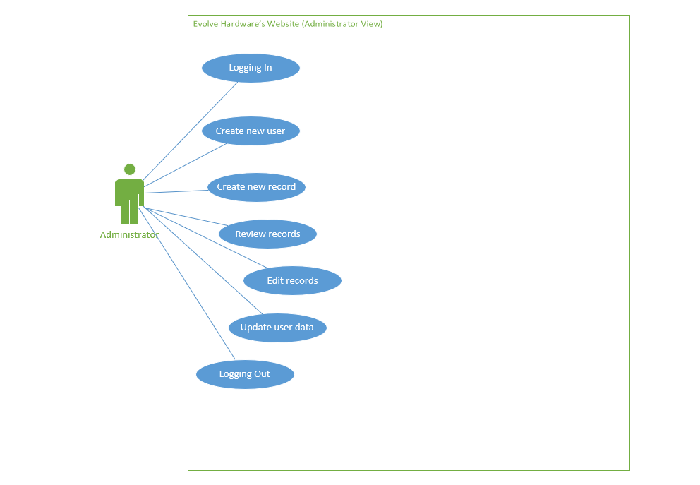

**Customer Service Staff Use Case Diagram**:

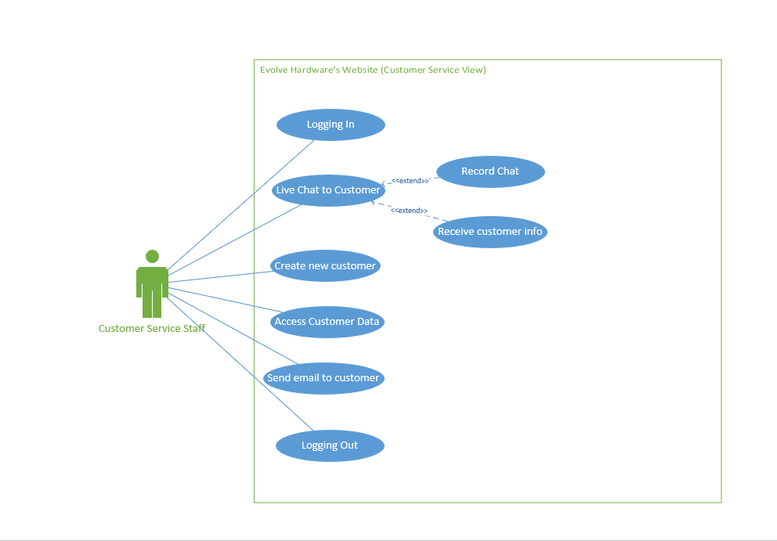

# **Activity Diagrams**

Live Chat to Customer Service Staff Activity Diagram:

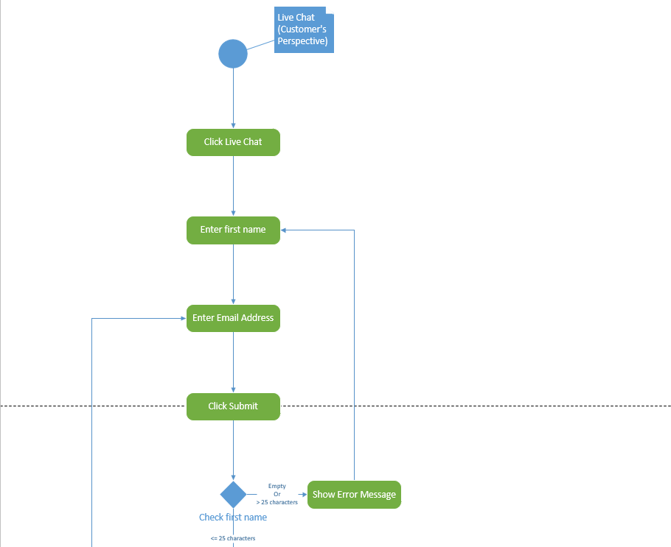

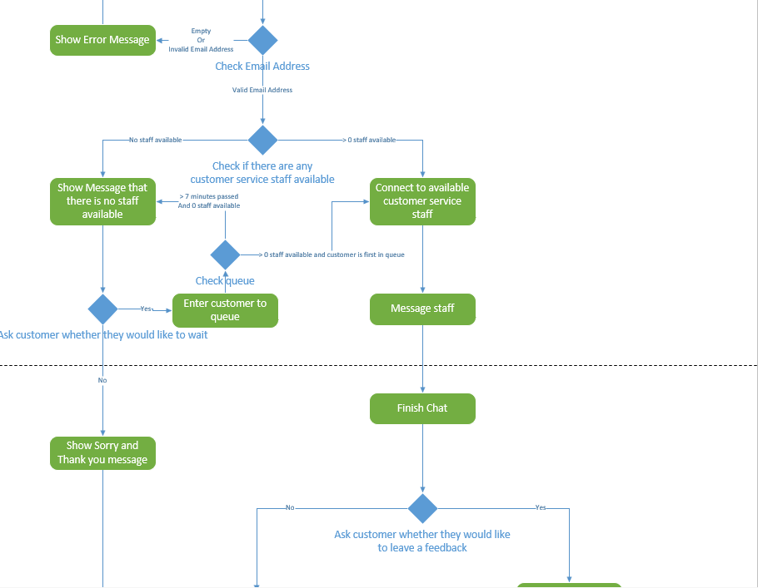

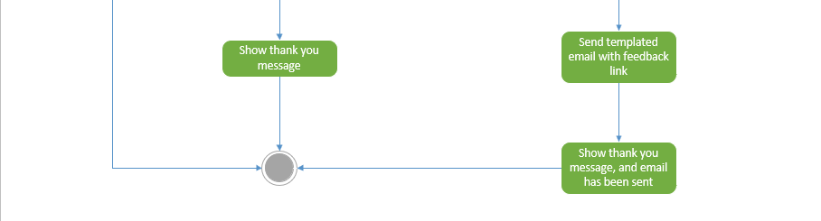

**Create new user**:

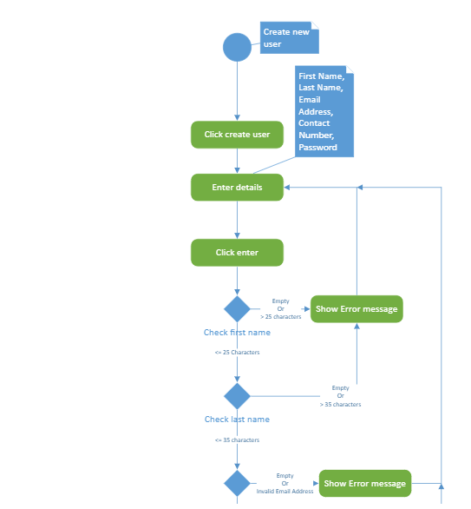

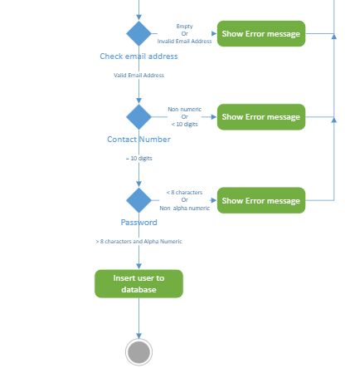

**Review Product**:

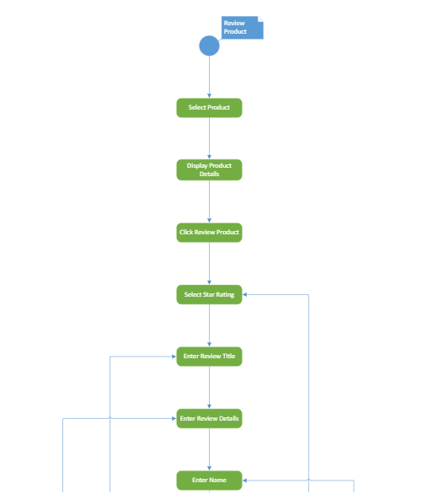

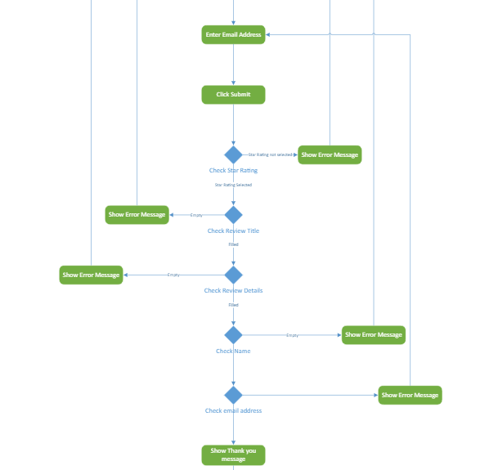



# 

# 

# **Use Case Descriptions**

1. Review Product Use Case Description

|  |  |
| --- | --- |
| Use Case Name: | Review Product |

|  |
| --- |
| 1. Description (Provide a brief description of this Use Case) |
| This use case will allow the user to view a product and its details, to enter their own details such as their name, email, review title, review, as well as a star rating to leave feedback for the product |

|  |
| --- |
| 2. Actors – (add lines as needed) |
| Actor 1: Customer  Actor 2: |

|  |
| --- |
| 3. Assumptions / Constraints - Judgments concerning unknown factors and the future which are made in analyzing alternative courses of action, or outside of the control of the project team |
| 1. N/A  2. N/A |

|  |
| --- |
| 4. Pre-Conditions (What conditions must be present before this Use Case can be used? What triggers the Use Case?): |
| 1. The user has accessed the website  2. The user has opted to click the option to leave a review |

|  |  |  |  |
| --- | --- | --- | --- |
| 5. Basic Flow (Describe the most common version of this Use Case. Add lines as needed): | | | |
| Flow Identifier: | | Reviewing Product | |
| Step | User Action | | System Response (optional) |
| 1 | Select Product | | Display product and details |
| 2 | Click Review Product | | Expand page further and display review template |
| 3 | Enter Review Details and Identification Details | |  |
| 4 | Click Submit | | Display Thank you message |
|  |  |  |  |

|  |  |  |  |
| --- | --- | --- | --- |
| 6. Alternative Flows (Describe other allowed variations of the Primary Use Case. Add additional flow identifier blocks as needed): | | | |
| Flow Identifier: | | <Enter alternative flow name and brief descriptor here> | |
| Step | User Action | | System Response (optional) |
| 1 |  | |  |
| Flow Identifier: | | <Enter alternative flow name and brief descriptor here> | |
| Step | User Action | | System Response (optional) |
| 1 |  | |  |
|  |  |  |  |

|  |  |  |
| --- | --- | --- |
| 7. Exception Flows (Describe Error Conditions. Add additional flow identifier blocks as needed): | | |
| Flow Identifier: Empty selection validation | | |
| Step | User Action | System Response (optional) |
| 1 | Star rating not selected | Error message |
| 2 | Review Title Empty | Error message |
| 3 | Review Details Empty | Error message |
| 4 | Name empty | Error message |
| 5 | Email Address Empty | Error message |

|  |
| --- |
| 8. “Includes” Use-Cases – (list use cases that are included in the flows listed above) |
| 1. Including view product use case  2. |

|  |
| --- |
| 9. Post-Condition – (list state of system and outputs at end of this use case) |
| This use case can end with any one of the following post-conditions:  1. All fields are validated and user has clicked submit  2. Display thank you message |

|  |
| --- |
| 10. Comments/Concerns/Issues/Notes |
|  |

|  |
| --- |
| 11. Created by- (name and date) |
| Cole Biglang-awa  2022/11/24 |

1. Live Chat to Customer Use Case Description

|  |  |
| --- | --- |
| Use Case Name: | Live Chat (Customer Perspective) |

|  |
| --- |
| 1. Description (Provide a brief description of this Use Case) |
| Allows the user to interact with the customer service and leave feedback about the products |

|  |
| --- |
| 2. Actors – (add lines as needed) |
| Actor 1: Customer  Actor 2: Customer Service Representative |

|  |
| --- |
| 3. Assumptions / Constraints - Judgments concerning unknown factors and the future which are made in analyzing alternative courses of action, or outside of the control of the project team |
|  |

|  |
| --- |
| 4. Pre-Conditions (What conditions must be present before this Use Case can be used? What triggers the Use Case?): |
| 1. The user has access to the website.  2. |

|  |  |  |  |
| --- | --- | --- | --- |
| 5. Basic Flow (Describe the most common version of this Use Case. Add lines as needed): | | | |
| Flow Identifier: | | <Live chat, this flow is where the user don’t have to wait> | |
| Step | User Action | | System Response (optional) |
| 1 | Click Live Chat | | Prompt for first name and email address |
| 2 | Enter first name | |  |
|  | Enter email address | |  |
| 3 | Click submit | | Check for errors, if there are errors prompt for first name and email again. If there is staff available then connect to them. |
| 4 | Message Staff | |  |
| 5 | Finish chat | | Send template email with the feedback link |
| 6 | Fill and send the feedback template | | Thank you message |
|  |  |  |  |

|  |  |  |  |
| --- | --- | --- | --- |
| 6. Alternative Flows (Describe other allowed variations of the Primary Use Case. Add additional flow identifier blocks as needed): | | | |
| Flow Identifier: | | <Live chat when they leave when there is no available staff> | |
| Step | User Action | | System Response (optional) |
| 1 | Click Live Chat | | Prompt for first name and email address |
| 2 | Enter first name | |  |
|  | Enter email address | |  |
| 3 | Click submit | | Check for errors, if there are errors prompt for first name and email again. If there is no staff available then show massage and ask whether they want to wait or not. |
| 4 | Decide they don’t want to wait | | Show a goodbye message, exit live chat |
| Flow Identifier: | | <live chat when they wait through the queue> | |
| Step | User Action | | System Response (optional) |
| 1 | Click Live Chat | | Prompt for first name and email address |
| 2 | Enter first name | |  |
|  | Enter email address | |  |
| 3 | Click submit | | Check for errors, if there are errors prompt for first name and email again. If there is no staff available then show massage and ask whether they wanna wait or not. |
| 4 | Decide they want to wait | | Place customer in queue, connect them to the next available customer service staff. After 7 minutes on the queue ask them again if they want to wait. |
| 5 | Message Staff | |  |
| 6 | Finish chat | | Prompt the user if they want to leave a feedback or not |
| 7 | Show thank you message | | Send thank you and goodbye message if they don’t want to send feedback |
|  |  |  |  |

|  |  |  |
| --- | --- | --- |
| 7. Exception Flows (Describe Error Conditions. Add additional flow identifier blocks as needed): | | |
| Flow Identifier: <validation for first and email address> | | |
| Step | User Action | System Response (optional) |
| 1 | Left first name empty | Error message, prompt for the first name |
| 2 | Left email address empty | Error message, prompt for the email |
| 3 | Enter invalid email address | Error message, focus to email address text box |
| 4 | Enter first name > 25 characters | Error message, focus to first name text box |

|  |
| --- |
| 8. “Includes” Use-Cases – (list use cases that are included in the flows listed above) |
|  |

|  |
| --- |
| 9. Post-Condition – (list state of system and outputs at end of this use case) |
| This use case can end with any one of the following post-conditions:  1. Thank you message  2. Thank you message with feed link |

|  |
| --- |
| 10. Comments/Concerns/Issues/Notes |
|  |

|  |
| --- |
| 11. Created by- (name and date) |
| Alejandro Perez. 24/11/2022 |

# 

# **Class Diagram**

